SOCI Receives In-Conversion (IC1) Certification and Tangible Success with ‘Soorty Organic Cotton Initiative’
In Partnership with WWF-Pakistan, the Department of Agricultural Extension, Balochistan and the Organic Cotton Accelerator

(UNITED STATES - April, 2022) – In mid-2021, Soorty, Pakistan’s largest vertically integrated denim company, launched the Soorty Organic Cotton Initiative (SOCI) and has been working closely with the Organic Cotton Accelerator (OCA) to bring more transparency to OC cultivation within the initiative. The company has recently received the In-Conversion Year-1 (IC1) Certification awarded by the Control Union (CU) for its first-year crop. Resultant premium payouts will help farmers in their transition and provide tangible benefits and incentives to take up organic farming, leading ultimately to an expansion in Pakistan’s role in the international OC trade.

Witnessing the success and building on the lessons learned, the private sector – most notably the textile sector – has come out in enthusiastic support of this transition. The first private sector project set up to facilitate this shift is the Soorty Organic Cotton Initiative (SOCI) funded and managed by Soorty Enterprises. SOCI is being implemented in the town of Naal, Balochistan in partnership with WWF-Pakistan and the Government of Balochistan along with support and input from the Laudes Foundation. The project has also partnered with Organic Cotton Accelerator (OCA) – a multi-stakeholder organization that is committed to bringing integrity, supply security and measurable social and environmental impact to organic cotton cultivation – to add its muscle to this task.

Almost a thousand farmers from Naal have transitioned to this safer method of producing cotton through SOCI over the last year. And with Year-2’s sowing underway, Soorty has worked with its partners to provide quality non-GM seed to the farmers to overcome a critical bottleneck in OC expansion in Pakistan. This year, SOCI will be rescuing an area of more than 7,000 acres from conventional farming to hopefully produce over 5,600 metric tons of Seed Cotton. But, perhaps most importantly, it will help create an infrastructure for dependable, local access to organic cotton seeds.

As a growing consumer consciousness and preference for responsibly and ethically sourced products becomes the norm, denim is undergoing a profound revolution. The use of Organic Cotton has acquired unique favor for the entire denim value chain – from retailers to brands, manufacturers, and consumers in recent years. The use of regenerative practices – with fewer, if any, chemicals, or fertilizers – to reap a rich and healthy crop isn’t just environmentally and socially responsible but making conscious practices mainstream and the sale of these crops also translates, directly, into more income for farmers and societies.

Despite its many advantages, the global cotton industry has been slow to incorporate organic practices. Major reasons are the mental and skill shift required to make the transition, seed availability, and certification. Organic cultivation does away with any chemical-based solution and depends on biofertilizers and biopesticides the farmers can make for themselves if they know how. Organic cotton is grown using genetically non-modified seeds but its cultivation is still less than 1% of total cotton cultivation worldwide. Meaning there is that much less organic cotton seed grown & even less than that is available for sowing due to mishandling, damage or losses in the ginning process. Responsibly grown cotton that can be certified as organic needs soil that is completely free from trace chemicals. In some cases, it can take up to 4 years of diligently following responsible practices before a certifiable organic cotton bulb even springs forth.

“SOCI is proving to be a game-changer, not just for Naal, but for the Organic Cotton trade”, says Mr. Asad Soorty, Director at Soorty Enterprises. “We’re very happy that, through their efforts, farmers from Khuzdar have been able to secure the In-Conversion (IC1) certification for their cotton and, because of this, access to a bigger premium payout and a chance for upward mobility for the community. I’m sure that the opening of this new cultivation area will also go a long way towards addressing the global shortage of Organic Cotton”.

Director General of WWF-Pakistan, Mr. Hammad Naqi Khan said, “The cultivation of Organic Cotton has a net-positive impact on the environment and that goal features prominently within my organization’s mandate. SOCI is developing into a big success story, especially after its In-Conversion (IC1) recognition and we look forward to working closely with Soorty to see the day when SOCI yields certified Organic cotton in Pakistan.”

The growing boom in the international organic trade market translates directly into a better quality of life for people of this underserved region and, with the advent of organic cotton, the private sector is primed to invest in a green energy because of the growing importance of Balochistan. The transition to organic cotton cultivation is about more than just cotton; in a country that depends so heavily on cotton product export, there is life changing potential inherent to this shift.

Soorty and their partners welcome guests and customers to hear more about their work at Soorty’s new creative room in Flatiron NYC, SpaceD as well as its other office and showrooms around the world, including NASDA Amsterdam and Turkey. Soorty’s SpaceD serves as a meeting location for brands and conscious individuals to actively meet new, innovative, game changing creatives, and to build valuable collaborations and partnerships for the future. Aiming to accelerate progress towards a sustainable denim sector, in which denim clothing and fabrics are used smartly and economically, and waste and pollution are kept to a minimum, Soorty is committed to sustainable denim production, at scale. Soorty define themselves as engineers at heart with a need to be restorative by design. Innovation is a radical responsibility and they are crafting the future with this consciousness, step by step, every single day.

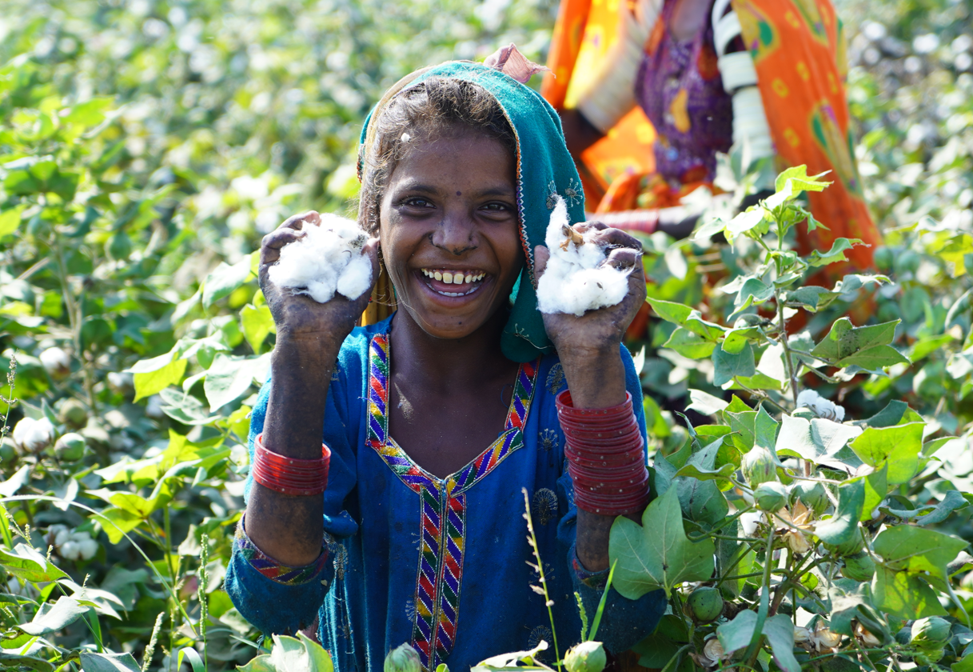

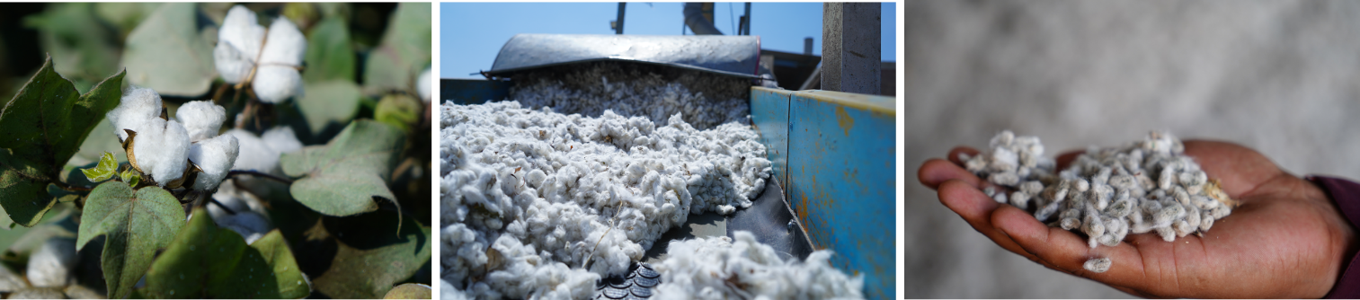

Imagery Courtesy of Soorty HERE

About Soorty:
Soorty is a family of engineers and designers who are passionate about creating denim that makes people look and feel good by imbuing its core values of innovation, design, and sustainability. Believing that sustainable denim needs to be manufactured at scale, Soorty is using its comprehensive vertically integrated infrastructure spanning Pakistan, Turkey, and Bangladesh to do just that. The company offers LEED certified production in cost-leading countries Pakistan and Bangladesh, a co-creation development facility in the hub of denim innovation Turkey, and design centers in the denim fashion hubs of the world - New York and Amsterdam. It has developed a strong foothold in European and US markets, producing for high street as well as premium brands in these regions.

Soorty is the only company to have LEED Platinum and Cradle2Cradle Gold certification across both its denim fabric mill and garment factory, a testament to its commitment to the circular economy and mass sustainable production.

Soorty uses its extensive factory floors as spaces for social change. Under its Prism Project, it has hired persons with hearing impairment in high-noise areas in its laundry, flipping disabilities into strengths. Its SEWS program uses a traveling street theater to sensitize male members of under-privileged households to the benefits of female employment, to bring a paradigm shift in women labor force participation in Pakistan.

Soorty Organic Cotton Initiative, SOCI, is Soorty’s recent venture into organic cotton farming. Covering over a thousand farmers, SOCI will not only build capacity for organic cotton, but also enhance livelihoods through financial inclusion, women vocational training and access to clean water.

NASDA Green Energy limited is Soorty Group’s venture into wind power. Starting April 2022, this will produce 50 MW of renewable energy for evacuation through the national grid to unelectrified rural neighborhoods.

@soortyenterprises @future.possibilities @SoortyCSR
future-possibilities.com
soorty.com

