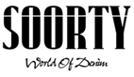

Soorty and Green Story Partnership on Life Cycle Analysis
Continues to Innovate with Sustainability and Production Practices

July 2021 – Soorty, Pakistan's largest vertically integrated denim producer, is pleased to announce their partnership with Green Story on an extensive Life Cycle Analysis of their products. This will show how and why making smart denim purchases can help society on a more responsible journey.

Driven by the goal to have every customer make environmentally and socially conscious choices, Green Story uses data-led advanced technology to measure the impact of production process and brings them together with easy-to-understand visuals to transform the customer experience and sustainable journey every step of the way. Using the global standard of Life Cycle Analysis methodology with data sourced from accredited partners around the world, Green Story brings the highest possible accuracy and transparency to their work, seamlessly integrating the results on different platforms to provide education on sustainability & brand credibility. From life cycle analysis and impact measurement to carbon offsetting with verified projects, every touchpoint allows the customer to consider: What is my impact?

As one of the largest vertical denim manufacturers in the world and by using data-driven transparency as their guide, Soorty knows that production at scale has the power to change things. Soorty sees and understands the need to be adaptable and fluid in skills and practices and uses technology as a tool to re-shape the systems as well as products. They are dedicated to making their impact on the environment and societies, a positive one, by using less of what is limited while making more and better use of it. Soorty has always put in the extra effort to educate the final customer. They have conducted workshops, attended design events, coordinated pop – ups, etc. to inform the consumer about denim and how denim can be responsible. The core of future possibilities is transparent information.

Soorty and Green Story started working together on two pieces from Soorty’s collections and have gone into the detailed measurement of their impact and will continue to work on additional products. From fiber selection to every single production process through the final products was calculated. The research done at Green Story shows that conscious consumers enjoy knowing their impact in real and comparative terms. This data results in relatable sustainability metrics that convince consumers to buy now. The interactive data and impact visuals will inspire brand-customer affinity, increase conversion rates, and highlight Soorty’s green choices.

Technology and innovation are disrupting every sector and industry. Transparency and credible data are becoming key to convince increasingly skeptical consumers that fashion brands are indeed changing.

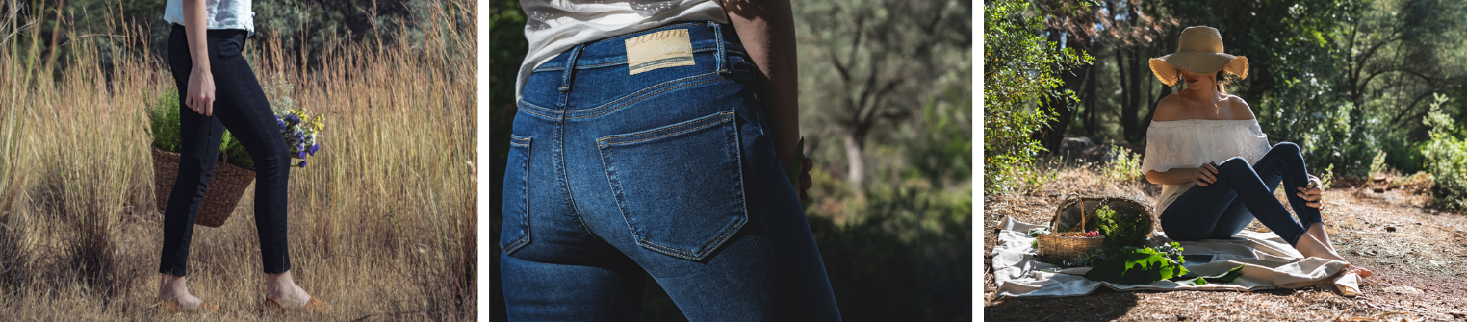
Imagery Courtesy of Soorty HERE

http://www.soorty.com
https://www.future-possibilities.com/
@soortyenterprises
For more information contact nicole@michelemariepr.com

About Soorty
Soorty is a family of engineers and designers who are passionate about creating denim that makes people look and feel good by imbuing its core values of innovation, design and sustainability. Believing that sustainable denim needs to be manufactured at scale, Soorty is using its comprehensive vertically integrated infrastructure spanning Pakistan, Turkey and Bangladesh to do just that. The company offers LEED certified production in cost-leading countries Pakistan and Bangladesh, a co-creation development facility in the hub of denim innovation Turkey, and design centers in the denim fashion hubs of the world - New York and Amsterdam. It has developed a strong foothold in European and US markets, producing for high street as well as premium brands in these regions.

Soorty is the only company to have LEED Platinum and Cradle2Cradle Gold certification across both its denim fabric mill and garment factory, a testament to its commitment to the circular economy and mass sustainable production.

Soorty uses its extensive factory floors as spaces for social change. Under its Prism Project, it has hired hearing impaired individuals in high-noise areas in its laundry, flipping disabilities into strengths. Its SEWS program uses a traveling street theater to sensitize male members of under-privileged households to the benefits of female employment, in order to bring a paradigm shift in women labor force participation in Pakistan.

Soorty Organic Cotton Initiative, SOCI, is Soorty’s recent venture into organic cotton farming. Covering 1000 farmers, SOCI will not only build capacity for organic cotton, but also enhance livelihoods through financial inclusion, women vocational training and access to clean water.

NASDA Green Energy limited is Soorty Group’s venture into wind power. Starting September 2021, this will produce 50 MW of renewable energy for evacuation through the national grid to unelectrified rural neighborhoods.

About Green Story
Green Story was founded with the vision of getting every consumer in the world to ask “What’s my impact?” before they make a purchase. By using credible data, an advanced technology platform and easy to understand visuals, Green Story transforms the customer experience every step of the way by showing the positive impact a customer can make by choosing green products. The company works with over 80 brands in 15 countries to calculate and show their impact to millions of consumers worldwide.

