Soorty and LENZING™ Collaborate on Capsule Collection: Reload in Blue

(NEW YORK, NY – January 31, 2022) -- Soorty, Pakistan’s largest vertically integrated denim company, has partnered with Lenzing, one of the largest man-made cellulosic fiber producers globally, to launch the Reload in Blue Collection.

Created using TENCEL™ lyocell innovated by nature fibers, the collection is designed around well-being, connectivity and conscious choices through loungewear and hybrid clothing with sustainable solutions. The core idea came from the hard experience we have all had to endure during the pandemic and being a learning process for so many people in the world. Clothing is yet another reminder of this unintended yet undeniable transformation. This collection embraces a capsule of stay-at-home clothing that offers a better feeling and look compared to PJs as well as work out sets of denim proving what a versatile fabric it can be when utilizing the correct materials and designed for purpose and hybrid clothing that will simply be the right mix between style and practicality. The exceedingly comfortable and elegant collection from Soorty and TENCEL™ Lyocell, is crafted with the finest materials to offer a space to enjoy and boost productivity. While continuing to define a new normal, there should not be a choice between city life and comfort, and both can be mutually inclusive.

While work attire continues in relaxed dressing, tactile luxurious special feeling fabrics and consciously engineered blends offer an elevated simplicity within our very own ultra-soft cocoons we have discovered. Therefore, product development and design for purpose was key for the capsule - using nature’s gifts in the correct blend for an ultimate composition weaving fabrics speaks for comfort, sustainability, consciousness, and style.
TENCEL ™ lyocell comes from Lenzing’s certified fiber production and is environmentally responsible and biodegradable. TENCEL™ lyocell is a fiber of botanic origins, produced from sustainable sourced wood with certifications using closed loop, environmentally responsible process. From jeans and shirting to accessories and athleisure, the recycled material creates apparel with a lower impact.

Soorty and Lenzing, two companies that normally have a supplier - buyer relationship moving out of their daily rhythm to join forces delivers a message much needed to be heard: “collective action and collaborative effort is what we need to drive the change for the better. We’ve designed, dreamed, and produced Reload in Blue to be a welcoming collection, and this was reflected to every detail of the collection - from fiber blends of the fabrics to style choices, from the washes to the care labels that give hints on how to extend products’ lifecycle, every single detail was driven by purpose. Being a strong believer of partnerships and SDG17, Soorty knows that only by working together with those we share values with, only by really understanding the struggles and advantages of one another and helping where needed we can transform our supply chain into a value chain. Reload In Blue and our partnership with TENCEL™ has been an invaluable example of this.” — Eda Dikmen, Marketing & Communications Manager, Soorty Enterprises
“Globally we have been facing such challenging times. Reload in Blue represents the current ethos where we need to recharge our lives with goodness. The feeling from within is reflected in the choices we made in apparel. The rich emotion of denim connects to the best moments of life which Reload in Blue brings together.” - Tricia Carey, Director of Global Business Development, Lenzing.
The collaboration combines the revolutionary and naturally innovative materials of TENCEL™ Lyocell with Soorty’s purpose driven mindset and vertical capabilities. Designed in Soorty’s new, purpose driven location, SpaceD NY and produced in their innovation lab in Çorlu, Turkey it taps into a true passion for fashion solutions that never sacrifice looking good while upping their responsibility and sustainability game. Being truly at the forefront of sustainability, inclusivity, technology, and education, both brands are always evolving and launching different initiatives that focus on a responsible transformation of the industry.

Soorty and Lenzing welcome guests and customers to view the tailor-made capsule collection at their new creative room in Flatiron NYC, SpaceD as well as the Lenzing offices in the Garment Center, NYC. Soorty’s SpaceD serves as a meeting location for the brands and conscious individuals to actively meet new innovative, game changing creatives, and to build valuable collaborations and partnerships in the future. These brands aim to accelerate progress towards a sustainable denim sector, in which denim clothing and fabrics are used smartly and economically, and waste and pollution are kept to a minimum.

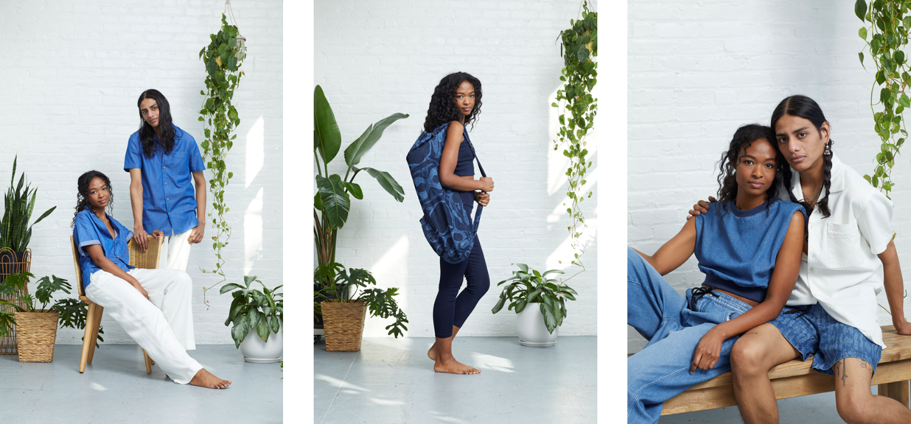
Link to Imagery HERE

About Soorty
Soorty is a family of engineers and designers who are passionate about creating denim that makes people look and feel good by imbuing its core values of innovation, design, and sustainability. Believing that sustainable denim needs to be manufactured at scale, Soorty is using its comprehensive vertically integrated infrastructure spanning Pakistan, Turkey, and Bangladesh to do just that. The company offers LEED certified production in cost-leading countries Pakistan and Bangladesh, a co-creation development facility in the hub of denim innovation Turkey, and design centers in the denim fashion hubs of the world - New York and Amsterdam. It has developed a strong foothold in European and US markets, producing for high street as well as premium brands in these regions.

Soorty is the only company to have LEED Platinum and Cradle2Cradle Gold certification across both its denim fabric mill and garment factory, a testament to its commitment to the circular economy and mass sustainable production.

Soorty uses its extensive factory floors as spaces for social change. Under its Prism Project, it has hired hearing impaired individuals in high-noise areas in its laundry, flipping disabilities into strengths. Its SEWS program uses a traveling street theater to sensitize male members of under-privileged households to the benefits of female employment, to bring a paradigm shift in women labor force participation in Pakistan.

Soorty Organic Cotton Initiative, SOCI, is Soorty’s recent venture into organic cotton farming. Covering 1000 farmers, SOCI will not only build capacity for organic cotton, but also enhance livelihoods through financial inclusion, women vocational training and access to clean water.

NASDA Green Energy limited is Soorty Group’s venture into wind power. Starting September 2021, this will produce 50 MW of renewable energy for evacuation through the national grid to unelectrified rural neighborhoods.

@soortyenterprises @future.possibilities
future-possibilities.com
soorty.com

About TENCEL™
TENCEL™ is the textile specialty brand under The Lenzing Group that covers textile specialty product fiber offerings for apparel and home. The TENCEL™ product brand portfolio defines a new evolutionary step in terms of sustainability, functional benefits, natural comfort and caters for distinctive everyday usage or application. Product brands under TENCEL™ include TENCEL™ Active, TENCEL™ Denim, TENCEL™ Home, TENCEL™ Intimate, TENCEL™ Luxe and TENCEL™ for Footwear.
Featuring botanic origin and biodegradable quality, TENCEL™ branded modal and lyocell fibers can enhance the breathability of fabrics and have a minimal static charge when used in fabrics. Fabrics made of TENCEL™ Modal and Lyocell fibers are also gentle on skin with smooth, long-lasting softness, color vibrancy and color retention features. TENCEL™ Lyocell fibers are versatile and can be combined with a wide range of textile fibers to enhance the aesthetics and functionality of fabrics. Through moisture management, TENCEL™ Lyocell fibers can also absorb moisture efficiently. A variant of the Lyocell production process also produces the TENCEL™ Luxe branded lyocell filament yarn, which is an extremely fine filament yarn for luxury fabrics and supremely smooth to the touch. Exhibiting high flexibility, TENCEL™ Modal fibers enhance textiles with a naturally soft quality. Offering endless design possibilities, TENCEL™ Modal fibers can be blended with other fibers and processed using conventional machinery, significantly improving the softness and comfort of fabrics.
Fibers and filaments used under the TENCEL™ brand are derived from certified and controlled sources following the stringent guidelines of the Lenzing Wood and Pulp Policy. Namely, TENCEL™ branded modal and lyocell fibers are produced via environmentally responsible production processes and are compostable and biodegradable, thus can fully revert to nature. They are designated by the USDA (U.S. Department of Agriculture) BioPreferred® Program. TENCEL™ Luxe is registered by The Vegan Society.

About the Lenzing Group
The Lenzing Group stands for ecologically responsible production of specialty fibers made from the renewable raw material wood. As an innovation leader, Lenzing is a partner of global textile and nonwoven manufacturers and drives many new technological developments.

The Lenzing Group’s high-quality fibers form the basis for a variety of textile applications ranging from elegant ladies clothing to versatile denims and high-performance sports clothing. Due to their consistent high quality, their biodegradability and compostability Lenzing fibers are also highly suitable for hygiene products and agricultural applications.
The business model of the Lenzing Group goes far beyond that of a traditional fiber producer. Together with its customers and partners, Lenzing develops innovative products along the value chain, creating added value for consumers. The Lenzing Group strives for the efficient utilization and processing of all raw materials and offers solutions to help redirect the textile sector towards a closed-loop economy. To reduce the speed of global warming and to accomplish the targets of the Paris Climate Agreement and the “Green Deal” of the EU Commission, Lenzing has a clear vision: namely to make a zero-carbon future come true.

For contacts and information
Nicole Clark – Michele Marie PR, Soorty Press contact: nicole@michelemariepr.com

