Soorty Launches ‘Soorty Organic Cotton Initiative’
In Partnership with WWF-Pakistan and the Department of Agriculture, Balochistan

UNITED STATES (March xx, 2021) Soorty, Pakistan's largest vertically integrated denim company, has launched the Soorty Organic Cotton Initiative (SOCI), their drive towards creating an organic cotton revolution. They’ve partnered with the pioneers of organic cotton farming in Pakistan - WWF-Pakistan, and the Department of Agriculture, Balochistan, along with support and input from the Laudes Foundation, for their latest project.
As a growing consumer consciousness and preference for responsibly and ethically sourced products becomes the norm, denim is undergoing a profound revolution. The use of Organic Cotton has acquired unique favor for the entire denim value chain – from retailers to brands, manufacturers, and consumers in recent years. The use of regenerative practices – with fewer, if any, chemicals, or fertilizers – to reap a rich and healthy crop isn’t just environmentally conscious but making conscious practices mainstream and the sale of these crops also translates, directly, into more income for farmers and societies.
Soorty Organic Cotton Initiative (SOCI) aims to reach out to all the farmers from the district of Balochistan to identify receptive communities looking to transform their small holdings into exclusively organic farmlands over the long term. Soorty has a different take on organic farming, and, with the help of its partners, are using their project as a vehicle for community uplift.
“SOCI goes beyond just cultivating organic cotton,” says Mr. Asad Soorty, Director at Soorty Enterprises. “SOCI is about uplifting the farming families of this deprived region through higher income, better schooling and access to professional health services. It’s about transforming the way cotton buying is conducted, by creating a blockchain-based transparent digital marketplace and traceability mechanism. This is our first foray into farming, and we’re excited by the possibilities in front of us.”
Senior Director of WWF-Pakistan, Dr. Masood Arshad, has also lauded Soorty’s role and project. He said, “we pay tribute to Soorty for its aspiration of promotions organic agriculture in Pakistan. Soorty has been with us since the first organic cotton bale was produced under Loudes Foundation’s initiative of organic cotton cultivation in Pakistan. That initiative has created a wave of organic cotton cultivation and its sourcing in Pakistan. We appreciate the commitment of the Department of Agriculture Extension, Govt of Balochistan, too. Now it is very encouraging that Soorty has joined hands with WWF-P and the Department of Agriculture Extension, Govt of Balochistan to scale up organic cotton cultivation which ultimately will help improve livelihoods of targeted poor farming communities and meet the demand of the world’s apparel industry. We hope this partnership will help accelerate organic cotton cultivation and will be a model for other local textile entities as well as international brands.”
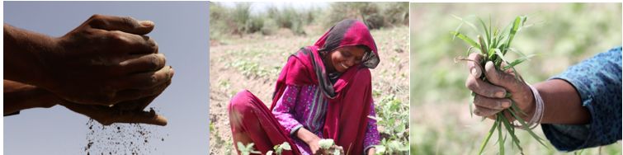Imagery Courtesy of Soorty HERE
The first project to be implemented in the region, under the SOCI umbrella, is at Nall - a sub-division of Khuzdar District of Balochistan. Almost 300 kilometers from the provincial capital – Quetta City. People from this largely rural region rely heavily on income from Agriculture and Husbandry to survive and basic government services like education, health and utilities are practically absent. Soorty plans to be an agent of positive change in the area through several health and education sector interventions to improve the quality of life for the locals. The project is slated to bring an area of approximately 7,000 acres under organic cultivation producing over 17,000 metric tons of Seed Cotton and 6,000 metric tons of Cotton Lint over the next four years. In order to ensure the integrity of the organic cotton, Soorty is putting emphasis on Blockchain-oriented transparency, tracking and traceability of our organic cotton along with rigorous and frequent GMO testing at every step of the chain.
Through the support of Soorty and their partners, are confident that local communities are primed for taking this leap successfully. Their hope is that this project will prove itself over time, and lead to other organizations taking on more community-focused responsibilities than they do at present.
http://www.soorty.com
https://www.future-possibilities.com/
@soortyenterprises
For more information contact julia@michelemariepr.

ABOUT SOORTY
Soorty is a family of engineers and designers at heart who need to communicate the possibility of crafting with sustainable innovation. Soorty is envisioning a new business model for the future of the denim industry; bringing the uniquely crafted engineering expertise together with contemporary communication tools that see, hear, and reflect the consumers' true needs, options, wants and desires.

Our understanding of sustainability is based on co-creating possibilities for radical responsibility. We are committed to disrupting the denim industry.

