Soorty and Left Hand Twill Collaborate on Own Your Denim - A Capsule That Comes With The World’s First Digital Vintage Collection

(NEW YORK, NY – March 2, 2022) -- Soorty, Pakistan’s largest vertically integrated denim company, has partnered with Solomon Russel, Founder of Left Hand Twill, a company built around a desire to conscientiously better the fashion consumption model in America, to launch the Own Your Denim Collection.

Left Hand Twill began as a vintage buying/selling company and has organically grown into a brand of itself. LHT’s objective is to reduce the pounds of textiles that are placed in landfills every year; by offering an array of finely curated vintage denim and denim accessories. LHT is dedicated to helping consumers find the perfect pair of jeans while expanding their knowledge on the vast world of denim.

As environmentally minded brands, LHT and Soorty worked together to showcase the viability of used clothing as an alternative to fashion goods that are sadly being perceived as disposables after a couple wears. The solution is to educate and provide more outreach to communities who are the prime buyers and create more of an attainable and responsible option. The capsule is a recreation of 10 selected pieces from Solomon Russel’s archive which were updated using only the most responsible denim fabrics woven with sustainable fibers using smart technologies. The patterns were prepared to recreate what was once vintage, geared for the modern wearer. Each piece has a beautifully written poem attached which are originally dedicated to people who are special to Solomon. This adds value to the existence of the collection with the idea of people owning their clothes — to realize that there is so much effort and value in each one of the pieces in the collection. Soorty used their capabilities to design laundry processes that use less of each limited material while making the best use of them. Every single piece is a responsible denim piece. Solomon and Soorty worked very closely during this entire process, paying close attention to every single detail. The teams ensured that the fit and silhouettes are size and body inclusive.

In addition to the physical pieces, Soorty utilized their 3D Evolution Studio where their highly talented experts are tackling the boundaries of digital fashion every day, and prepared digital pieces for each one of the garments in the capsule collection. This resulted in the first ever digital vintage collection there is, made specially for this purposeful capsule. The team has brought together the digital garments into two clips inspired by the big movies & cinema movement of the 70s. After the “golden age of Hollywood” ended in the early 60s, a new wave of cinema came up which gave power to a younger and more unpredictable group of directors & actors who weren’t afraid to reflect the changing culture of the time they lived in on to the big screen. Inspired by the days of disco and reflection of urban reality: raw, renewed & unfiltered, the 70s inspired transitional effects where each garment is introduced with an iconic yellow title like a main character/actor. This is a symbol of Solomon’s contribution to the dialogue about clothing and its’ relationship with American culture through his pieces.
So why connect vintage with digital fashion? The fashion industry has been undergoing large scale changes as a direct result of the rise of technology and its impact on consumer behavior. Technologies are changing the way people shop - through social media apps, retail shops, augmented realities… Creating a new and different experience sets brands apart from the rest in an over catered fashion world.

“OWN YOUR DENIM is about understanding our clothes’ real value - the effort, the labor & resource behind every single one of them. Attaching to our garments and forming real bonds that will extend the product life cycle. This is why collaborating with Solomon on this collection was an absolute pleasure for our entire team on so many levels - we’ve started with a journey to his archives, got to learn about denim pieces with an history, recreated them using only the most socially & environmentally responsible options we have, ensured all is inclusive so they’ll owned by us all, and prepared a branding that literally attaches sentiments to garments. The end product is something beautiful, prepared by us, for us… so you can’t just throw it away when (if you ever are) done with it. The most one can do is to gently pass it on to someone else who’ll love it for years to come. And that’s the whole aim.
And then, as a pioneer of digital fashion in the denim industry, we’ve challenged ourselves to take one more step further; to create the world’s first digital vintage collection. So happy to see how it all came together.” — Eda Dikmen, Marketing & Communications Manager, Soorty

Soorty and LHT welcome guests and customers to view the capsule collection at Soorty’s new creative room in Flatiron NYC, SpaceD. Soorty’s SpaceD serves as a meeting location for the brands and conscious individuals to actively meet new innovative, game changing creatives, and to build valuable collaborations and partnerships in the future. These brands aim to accelerate progress towards a sustainable denim sector, in which denim clothing and fabrics are used smartly and economically, and waste and pollution are kept to a minimum.
Soorty is committed to sustainable garment production at scale for denim garments while respecting our planet by using its resources smartly. Soorty defines themselves as engineers at heart with a need to be restorative by design. Innovation is radical responsibility and they are crafting the future with this consciousness, step by step, every single day. Collaborating with LHT and Solomon for this capsule collection is a very solid step in reaching sustainability goals and evolving with the digital times.

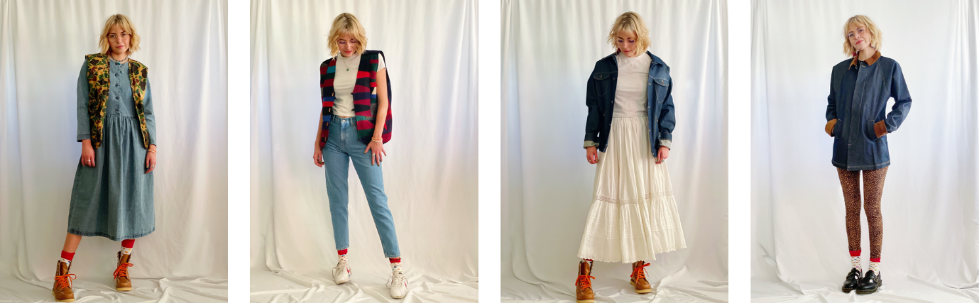
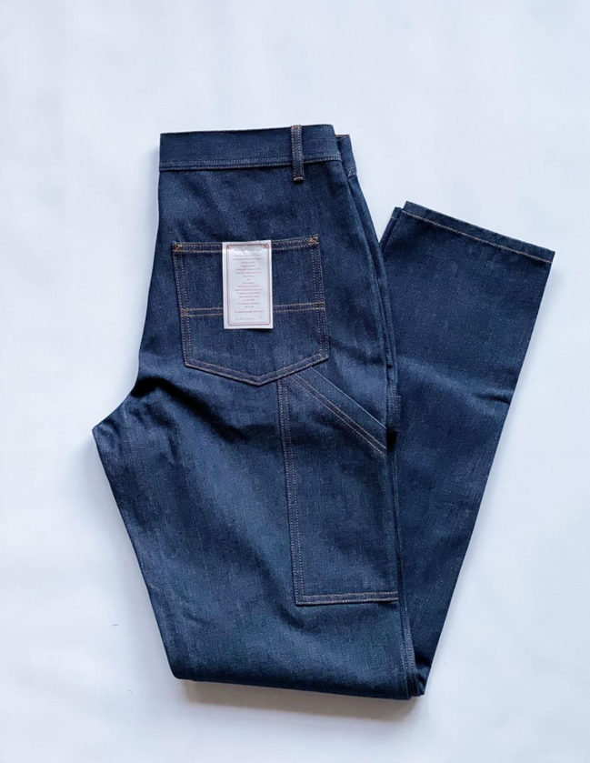

Link to Imagery HERE
About Soorty:
Soorty is a family of engineers and designers who are passionate about creating denim that makes people look and feel good by imbuing its core values of innovation, design, and sustainability. Believing that sustainable denim needs to be manufactured at scale, Soorty is using its comprehensive vertically integrated infrastructure spanning Pakistan, Turkey, and Bangladesh to do just that. The company offers LEED certified production in cost-leading countries Pakistan and Bangladesh, a co-creation development facility in the hub of denim innovation Turkey, and design centers in the denim fashion hubs of the world - New York and Amsterdam. It has developed a strong foothold in European and US markets, producing for high street as well as premium brands in these regions.

Soorty is the only company to have LEED Platinum and Cradle2Cradle Gold certification across both its denim fabric mill and garment factory, a testament to its commitment to the circular economy and mass sustainable production.

Soorty uses its extensive factory floors as spaces for social change. Under its Prism Project, it has hired hearing impaired individuals in high-noise areas in its laundry, flipping disabilities into strengths. Its SEWS program uses a traveling street theater to sensitize male members of under-privileged households to the benefits of female employment, to bring a paradigm shift in women labor force participation in Pakistan.

Soorty Organic Cotton Initiative, SOCI, is Soorty’s recent venture into organic cotton farming. Covering 1000 farmers, SOCI will not only build capacity for organic cotton, but also enhance livelihoods through financial inclusion, women vocational training and access to clean water.

NASDA Green Energy limited is Soorty Group’s venture into wind power. Starting September 2021, this will produce 50 MW of renewable energy for evacuation through the national grid to unelectrified rural neighborhoods.

@soortyenterprises @future.possibilities
future-possibilities.com
soorty.com

